**Solids, Liquids and Gases**

Complete the following table by writing 5 examples of solids, liquids and gases. One example of each has been done to get you started.

|  |  |  |
| --- | --- | --- |
| *Solids* | *Liquids* | *Gases* |
| Chocolate | Water | Nitrogen |

**Equipment**

* ice cube
* plastic syringe
* spatula
* balloon
* beaker of water
* beaker
* measuring cylinder

**Method**

Complete each activity then decide on the property.

*Ice cube*

1. Place the ice in a measuring cylinder and approximate its volume.
2. Transfer the ice cube to a beaker. Has its volume changed? Has its shape changed?
3. Pick up the ice cube and place it on the bench. Using a spatula, try to squash it or compress it to make it smaller.

*Water*

1. Using a measuring cylinder, measure out 100mL of water.
2. Transfer the water to a beaker. Has its volume changed? Has its shape changed?
3. Take the beaker of water and draw up a small amount into the syringe. Place your finger over the opening at the end of the syringe and press down on the plunger. Does the plunger move?

*Air*

1. Partially inflate a balloon with air and hold the opening tightly closed. Try to squeeze the balloon. Has its volume changed? Has its shape changed?
2. Release your hold on the opening of the balloon. Has its volume changed? Has its shape changed?

**States of Matter: Properties**

|  |  |  |  |
| --- | --- | --- | --- |
|  | *Solids* | *Liquids* | *Gases* |
| *Shape* | Fixed / Variable  Why? | Fixed / Variable  Why? | Fixed / Variable  Why? |
| *Volume* | Fixed / Variable  Why? | Fixed / Variable  Why? | Fixed / Variable  Why? |
| *Compressibility* | Yes / No  Why? | Yes / No  Why? | Yes / No  Why? |

**Why does this happen?**

All matter is made up of particles. In solids, liquids and gases, the particles behave differently.

*Solids*

In a solid, the particles are locked into place. Even though they are locked in place, they are still vibrating. If you add heat, they vibrate more because they have more energy.

*Liquids*

If you heat the solid, the particles will vibrate so much they can’t stay in their place any more. They start moving around. The solid has then melted into a liquid. If you add more heat, they want to move around even more because they have even more energy.

*Gases*

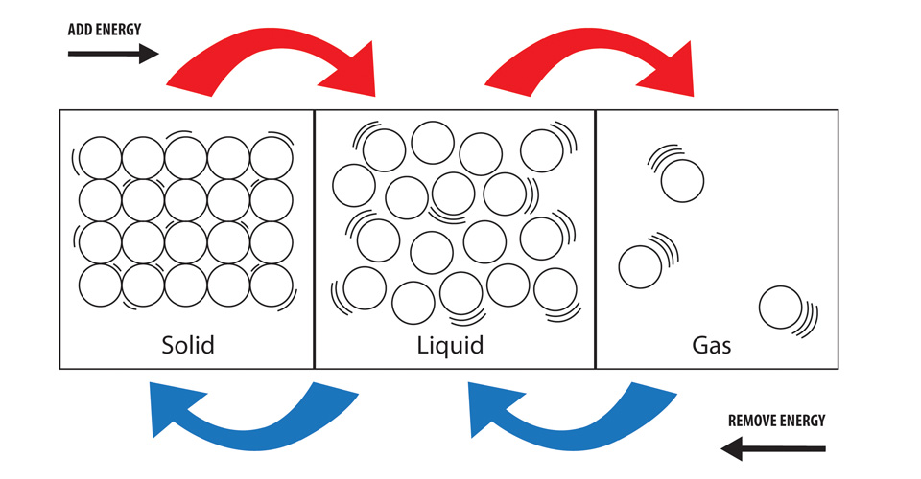The particles in a gas are free to move around and are not held by any other particles. Gases have no definite shape.